SpendWise

PROJECT TITLE
SpendWise – A Simple Backend Learning Project using Node.js, MongoDB and JWT
TEAM ID: SWTID-2026-3924
TEAM LEADER: SHARMILA S
REGISTER NUMBER: 212402991
NAAN MUDALVAN ID: 29B2196846630368E844DB3750D02359

TEAM MEMBER: SREEGA D
REGISTER NUMBER: 212402998
NAAN MUDALVAN ID: 21B96CE2D0A0BDAAEB74E617E75065A9
TEAM MEMBER: SWATHISREE C
REGISTER NUMBER: 212403002
NAAN MUDALVAN ID: 452BE171DA8636BA74D4854D157962CD


SpendWise

Project Title
SpendWise–ASimpleBackend Learning Project using Node.js, Express, MongoDB, and JWT

Project Overview
SpendWise is a backend application designed to help beginner developers learn how to build secure REST APIs using Node.js, Express, MongoDB, and JWT authentication. The project focuses on implementing user authentication and basic CRUD operations in a clean and simple way so students can understand how backend systems work in real-world scenarios. Key Objectives:

Provide secure user authentication using JWT
Enable basic CRUD operations on user data (transactions/records) Demonstrate MongoDB integration using Mongoose
Show how protected routes work using middleware
Maintain a simple and beginner-friendly backend architecture

Target Users:
Beginner backend developers Students learning Node.js and Express
Freshers preparing for technical interviews
Anyone who wants a simple project to understand JWT and MongoDB Learners who want hands-on practice with REST APIs

Project Instruction
SpendWiseisabackend-onlyproject built using Node.js and Express.

Quick Start:
npm init npm install npm run dev

Steps to Create the Project:
Choose or create a directory for the backend project. Open terminal and navigate to that directory.
Initialize Node.js project using npm init.
Install required packages: express, mongoose, jsonwebtoken, bcrypt, cors, dotenv. Create folders: models, routes, controllers, middleware, config.
Start the server using npm run dev.
Test APIs using Postman or Thunder Client at http://localhost:5000.

Pre-requisites:

Software Requirements

Software Purpose

Node.js

MongoDB
JavaScript runtime for backend

NoSQL database for data storage



npm Package manager

Git Version control system

Code Editor VS Code or similar

Knowledge Requirements
JavaScript ES6+ Node.js and Express.js
MongoDB and Mongoose JWT authentication
Basic REST API concepts Git basics

Thumbnail for Project
A simple backend project thumbnail representing:

Node.js + Express + MongoDB + JWT + CRUD APIs

Project Architecture Image

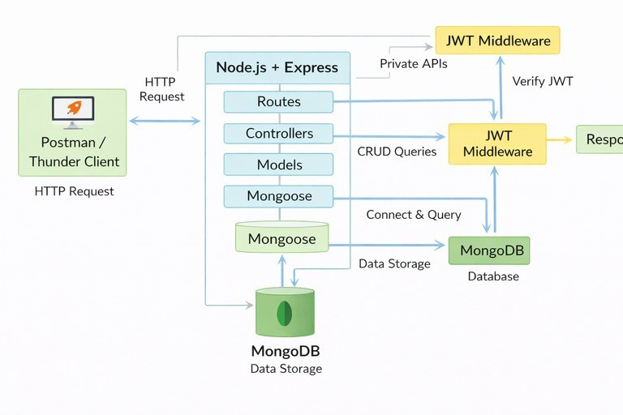

Technical Architecture

BackendArchitecture(Node.js+ Express)
Controllers: Handle business logic for authentication and CRUD
Models: Mongoose schemas for User and Transaction
Routes: APIendpoints for auth and CRUD operations
Middleware: JWT verification and request protection
Configuration: Database connection and environment variables

Database Architecture (MongoDB)
Users Collection: _id,name,email,password(hashed), createdAt
Transactions Collection: _id,userId(FK),title/description, amount/value, createdAt
Relationship: Many Transactions belong to One User

ER Diagram

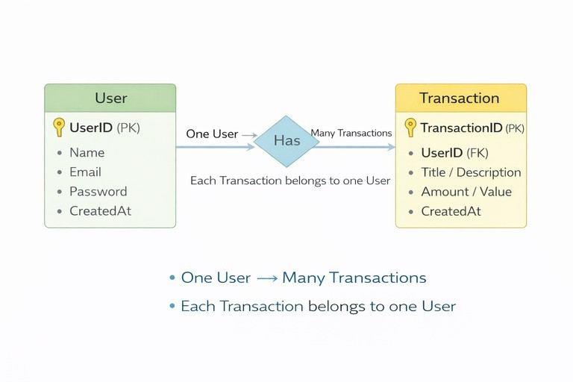

Features

# Feature Description

- User Authentication

- CRUD Operations

- Protected Routes

- MongoDB Integration
JWT-based registration and login

Create, Read, Update, Delete transactions

Secure APIs using JWT middleware

Store and fetch data using Mongoose



Roles and Responsibilities

Student / Developer:

Write backend code Create APIs
Test APIs using Postman/Thunder Client Push code to GitHub

System (Backend):
Authenticate users using JWT Handle CRUD operations
Store and fetch data from MongoDB Protect private routes

Users Flow:

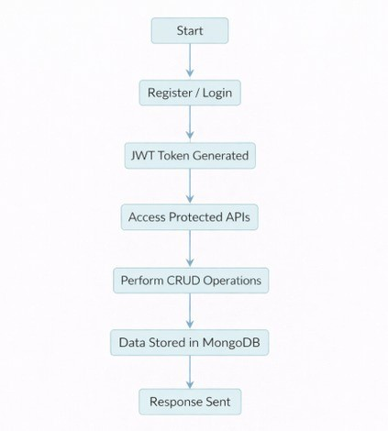

PROJECT SETUP AND CONFIGURATION
Folder Structure

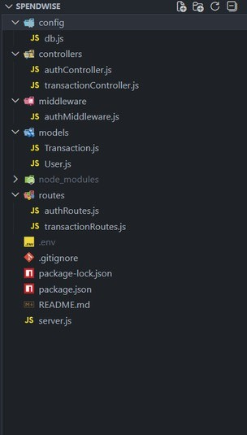

Project Setup
- Install required tools:
Node.js
MongoDB
- Create project folders:
server folders (models, routes, controllers, middleware, config)

- Install Backend Packages: Express
Mongoose Cors
Jsonwebtoken Bcrypt
Dotenv

BACKEND DEVELOPMENT
Setup Expressserver Create server.js file
Create .env file and define PORT and DB URL

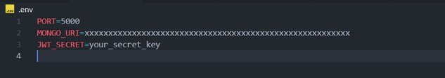

Configure middleware (cors, express.json) User Authentication:

Create Register and Login routes Generate JWT token
Protect routes using middleware

Define API Routes: Auth routes

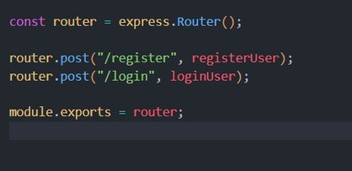

Transaction CRUD routes

Implement Data Models:


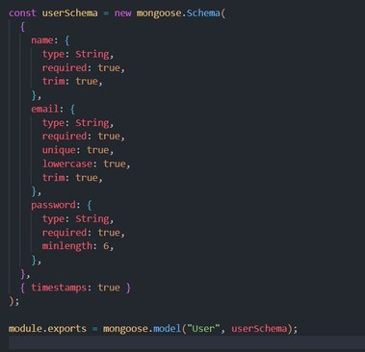
User schema

Transaction schema

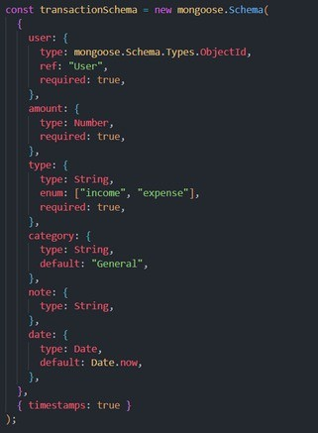

Implement CRUD operations Add basic error handling

DATABASE DEVELOPMENT

Configure MongoDB
Use MongoDB Atlas or local MongoDB Store connection URL in .env file
Connect using Mongoose

Create Database Connection
Create a config file for DB connection

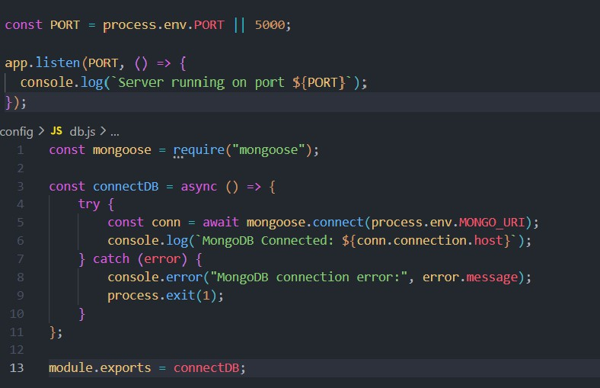
Use mongoose.connect()
Handle success and error cases

Create Schema and Models

User Model:

Name email
password

Data / Transaction Model:
userId
title / description amount / value timestamps

PROJECT EXECUTION
Project Execution Steps:

- Start MongoDB
- Run backend server

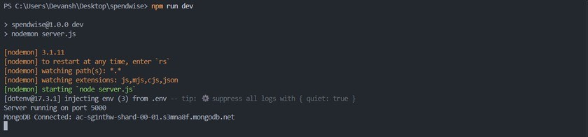

- Test Register API

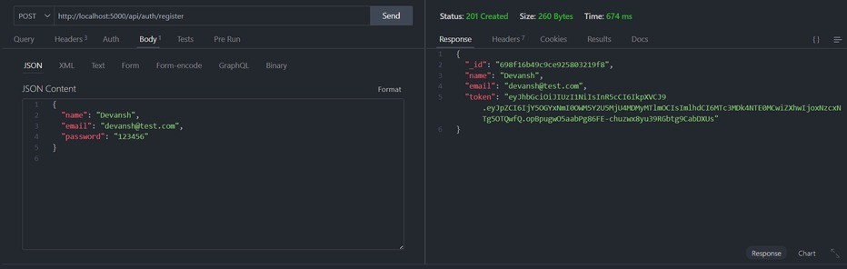

- Test Login API

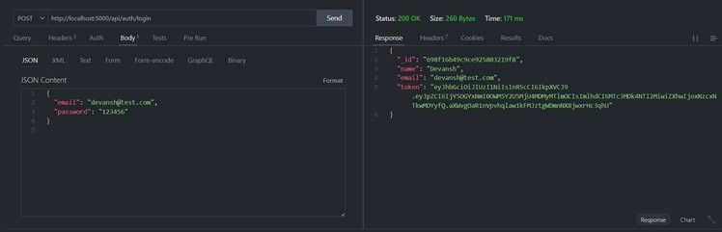

- Copy JWT token

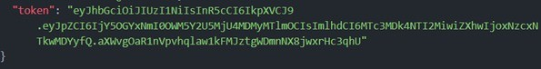

- Use token to access protected CRUD APIs
- Perform Create, Read, Update, Delete operations

OUTPUT SCREENSHOT

- Register API



- Login API



- Create Transaction

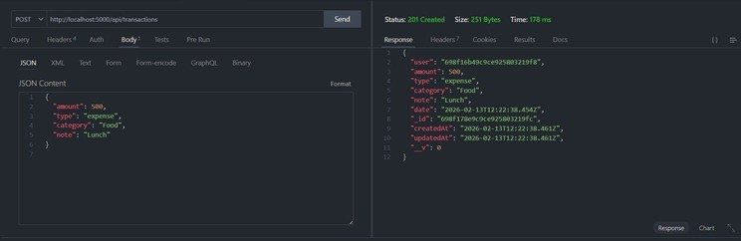

- Get information

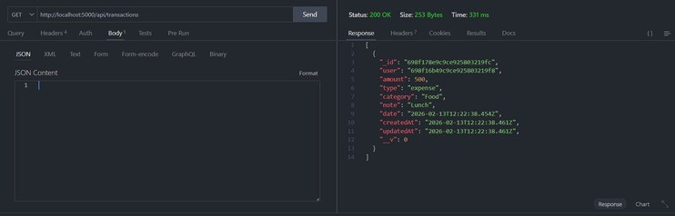

- Update API

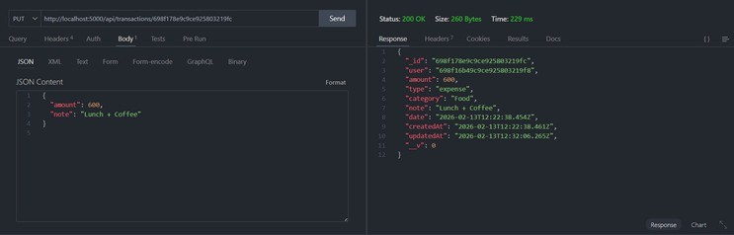

- Delete API

